

Visit Bangladesh

Technical-User Manual

**Visit Bangladesh**

**An Android App**

**Course: SE 505**

Submitted by

**S.M. Shahriyar (BSSE 0902)**

**Sudip Kumar Sah (BSSE 1040)**

Supervised by

**Dr. Sumon Ahmed**

***Assistant Professor***

**Institute of Information Technology**

**University of Dhaka**

**Date: 26/08/2021**

**Member 1:**

**Name:** Sudip Kumar Sah

**Roll:** BSSE-1040

**Registration Number:** 2016-718-933

**Contact:** 01323279848

**Email:** bsse0934@iit.du.ac.bd

**Member 2:**

**Name:** S M Shahriyar

**Roll:** BSSE-1044

**Registration Number:** 2016-115-031

**Contact:** 0152143243

**Email:** bsse0902@iit.du.ac.bd

# 

# **INTRODUCTION**

This project is a tourist guide app named as “VISIT BANGLADESH” app that can be used to visit and know about the various tourist places of Bangladesh.

With proper user- friendly interface and exciting features like currency, weather report, emergency contacting so on. An app already has some pre-updated tourists’ sites that can be added by user-related places in their locality. Navigation with google maps and calculating distances to tourist places can be updated with various routes to reach selected destinations by various means of transportation.

# 

# **Setup the project**

We had developed our android app (“Visit Bangladesh”) through android studio. To set up, this app in any android app. We have Apk file and can be sent and installed. Through apk, app can install.

## **Technical Manual**

### **Designs**

Authentication widget

This widget provides interface login/signup and creating user account.

Details of Places widget

This widget will fetch all information of a specific place and show into the app.

Google Maps widget

This will enables google maps and retrieve coordinates.

Adding new places widget

This widget provides UI for adding new places to firebase cloud firestore.

Weather update and Currency Converter

Both widgets run through navigation sidebar and open individually UI for both features.

Searching Place

Algorithm and Pages are designed to perform search by famous place name, division/district wise

### **Activities**

Authentication

email_register_page.dart

This will register a new user email and provide username.

email_login_page.dart

This will help user to login after authentication

MyUserAuth.dart

This will authenticate the user whether the previous account is created with same email or not.

Adding new places widget

add_tourist_place.dart

here, users are asked to input various information of tourist place like famous spot name, description, locally available police station and guide details etc.

add_image.dart

Adding details of places, same time related image needs to be updated from gallery or google drive

my_map.dart

Button click will open google maps and placed marker at map drag latitude and longitude to firebase database.

Google Maps widget

show_route_map.dart

When selecting a specific tourist to view details, in the bottom right corner, the button will navigate to the location in the map where that place is located. Also calculate distance.

Places details widget

Route Details, Police Station Details and Guide Details

details.dart

Created button and fetched from database using place model

place_model.dart

Interface for conversion of data into JSON and fetching information from JSON

Currency Converter and Emergency Contact

emergency_contract.dart

In this, there are some predefined help desk contacts and can make call directly from the app.

Currency_convert.dart

In this, user can convert almost more than 25 countries currencies from their native currencies

Weather Update

weatherPage.dart

Provide UI for weather page

detailPage.dart

Can change place and get updated weather of tourist place

Searching Place

grid_search.dart & search_widget.dart

Search performed by place name, or by their division/ district

# **USER MANUAL**

## **4.1 Login**

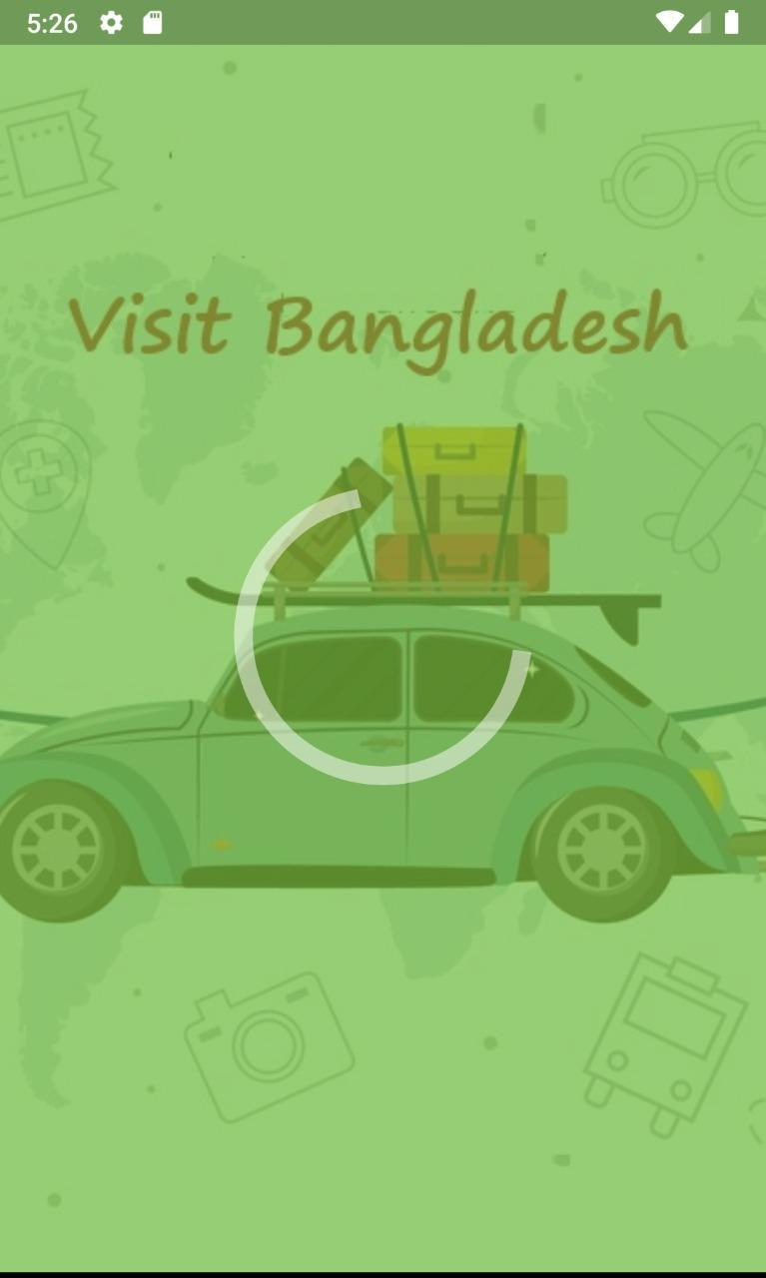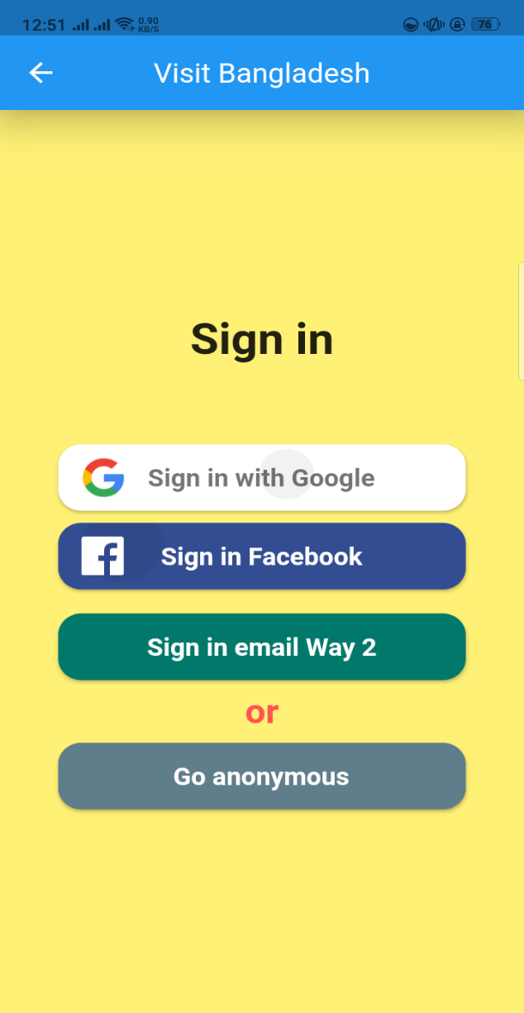

*Figure 48:Splash and Sign In*

By clicking app icon, we will be opened to login/signup page with splash page. You can enter anonymously or login with Gmail, further you will be opened to home page where there is navigation sidebar and welcome page.

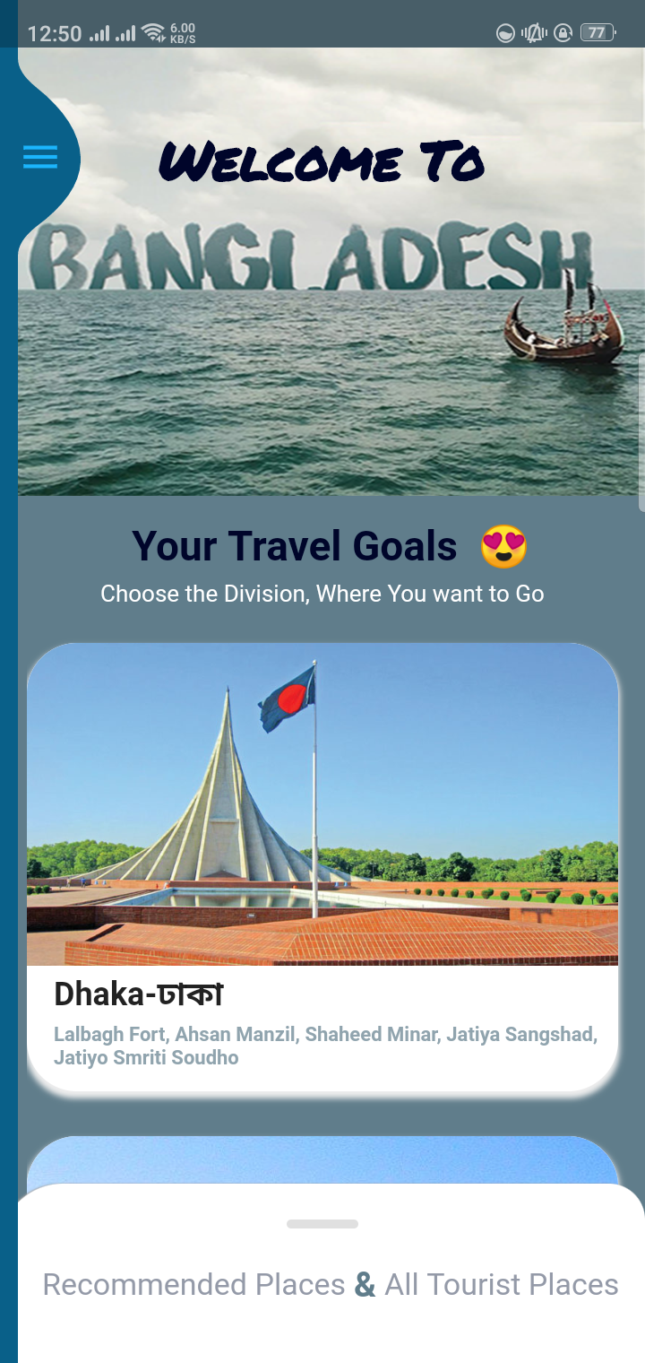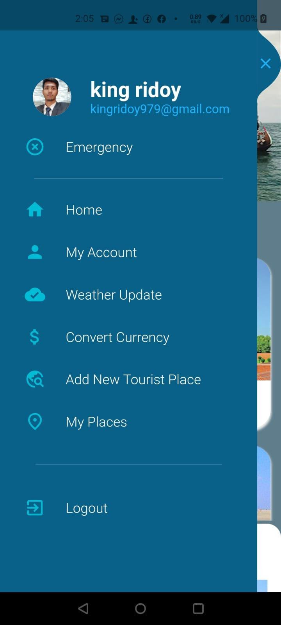

*Figure 49:Home Page & sidebar menu*

After log in we get the 3rd image, where there is landing page for app where all 8 divisions wise tourist places are available and recommended places with details. Here, navigation side bar has home page, my account details, Weather update, convert currency and add new tourist places pages.

## **4.2 My Account**

*Figure 50:User-Account Info*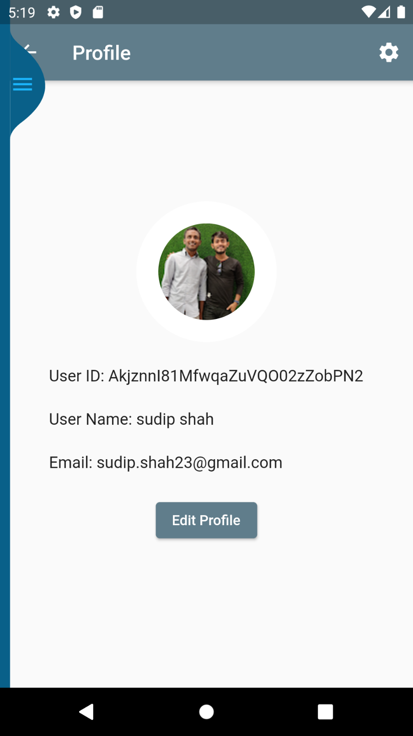

By clicking, my account in navigation sidebars, we will enter into new page where user details with their image, userid, username and email as well as options to edit profile are available. User must login with their Gmail otherwise, details are unavailable.

## **4.3 Weather Update**

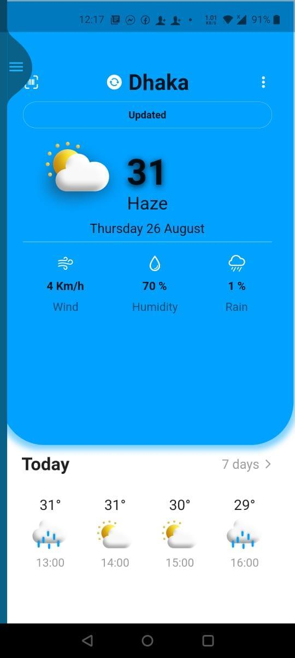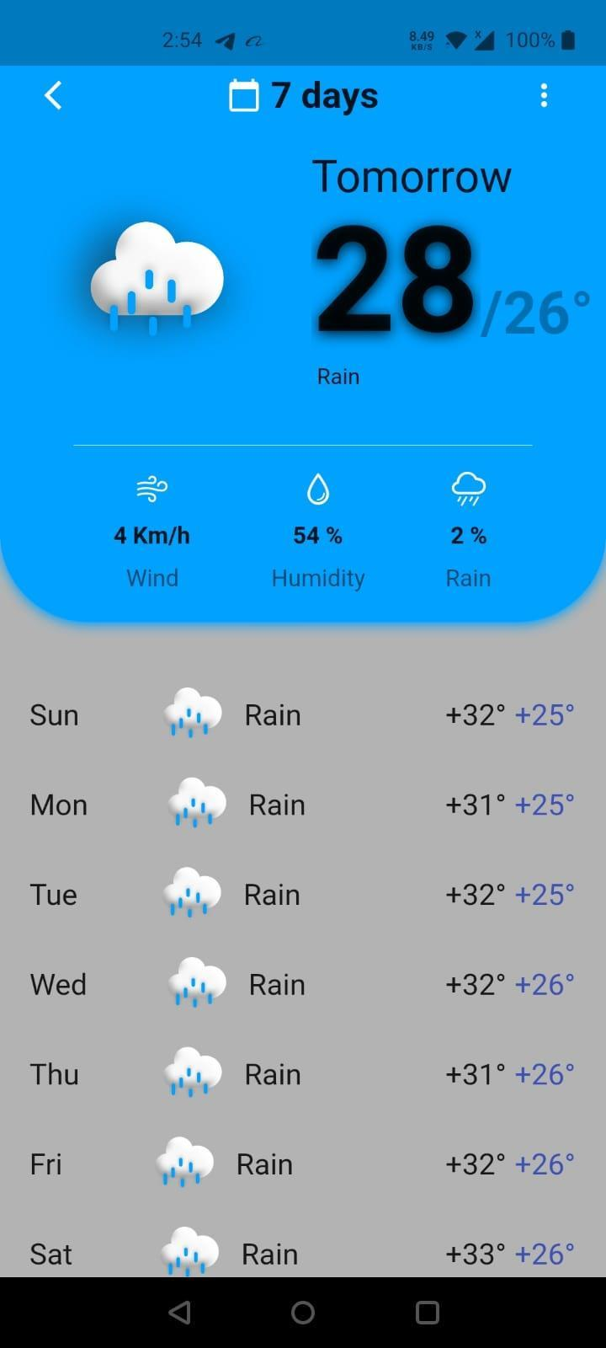

*Figure 51: Shows weather*

Here, user can see the update about weather of destined places for next days.

## **4.4 Currency Converter**

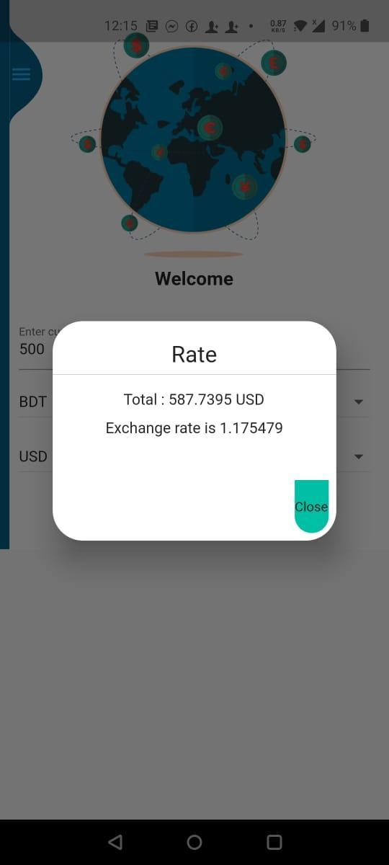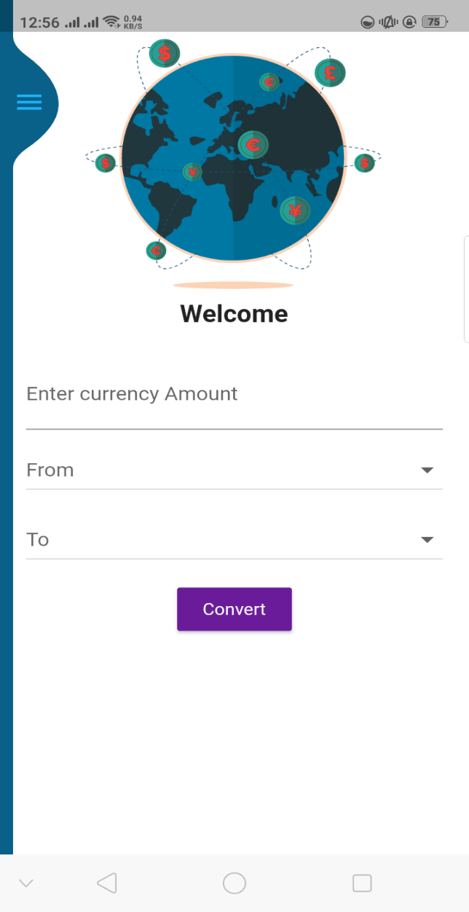

*Figure 52:Currency Converter Interface*

This feature is very helpful for the foreigners. You can easily navigate through sidebar. They have different currencies for which they easily convert to any currencies here entering amount and converting currencies.

## **4.4 Adding new tourist places**

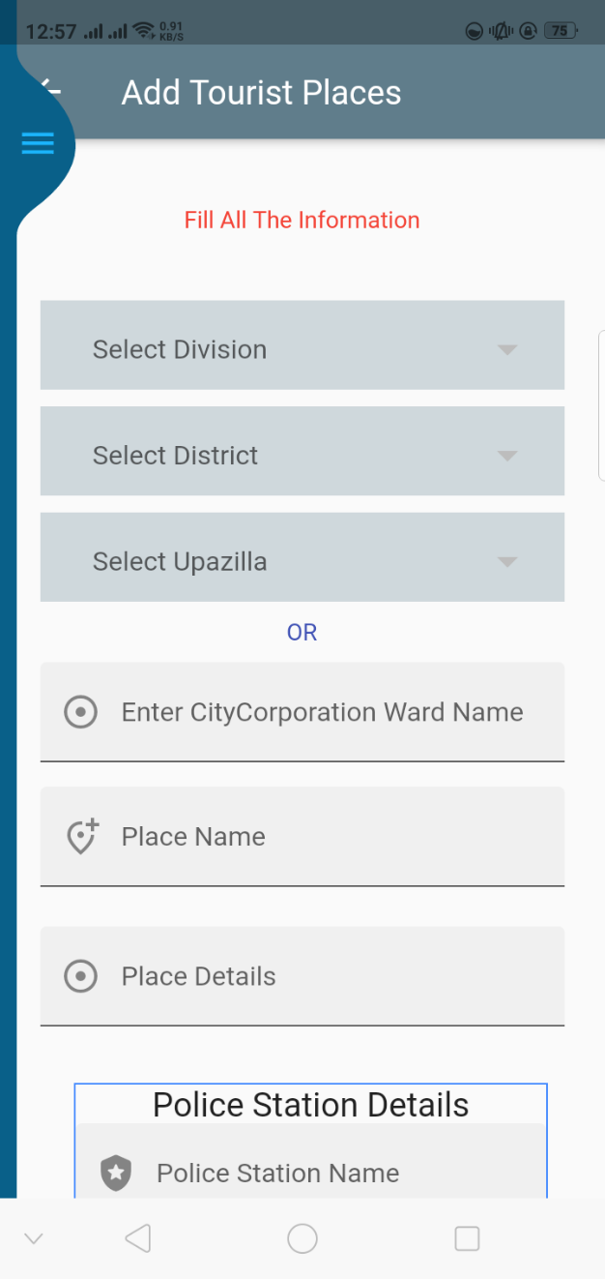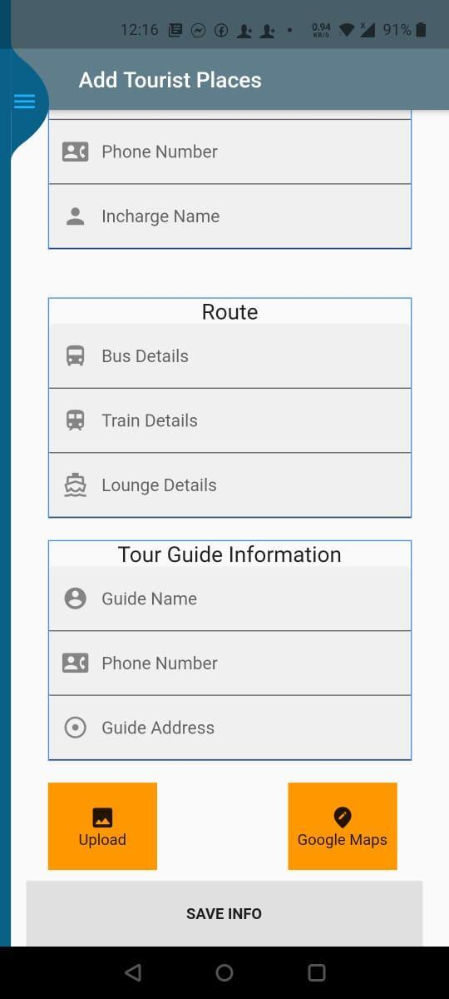

*Figure 53: Form Adding new places*

Navigating to this page, you will have a long form which will ask you to input valid details about various valid tourist places in your locality like division, district, route to reach there, famous place name and description about places, available police station details and tour guide information as well as attracting place’s images and location from google maps.

### Google Maps

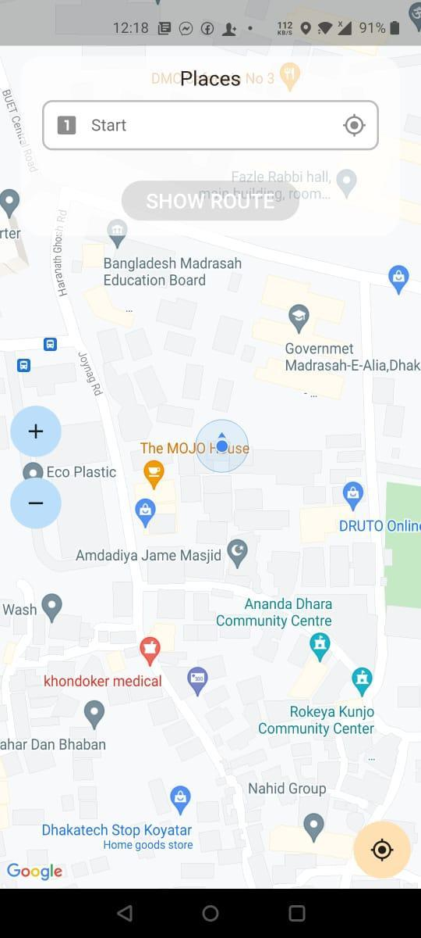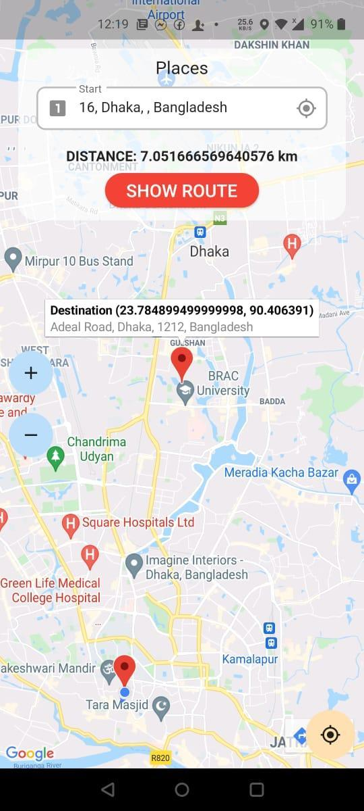

*Figure 54:Maps Navigation*

Opening Googles maps will helps to select places by dragging around tourist places and same coordinates will be updated to database of that tourist places. You can calculate distance.

### Upload Images

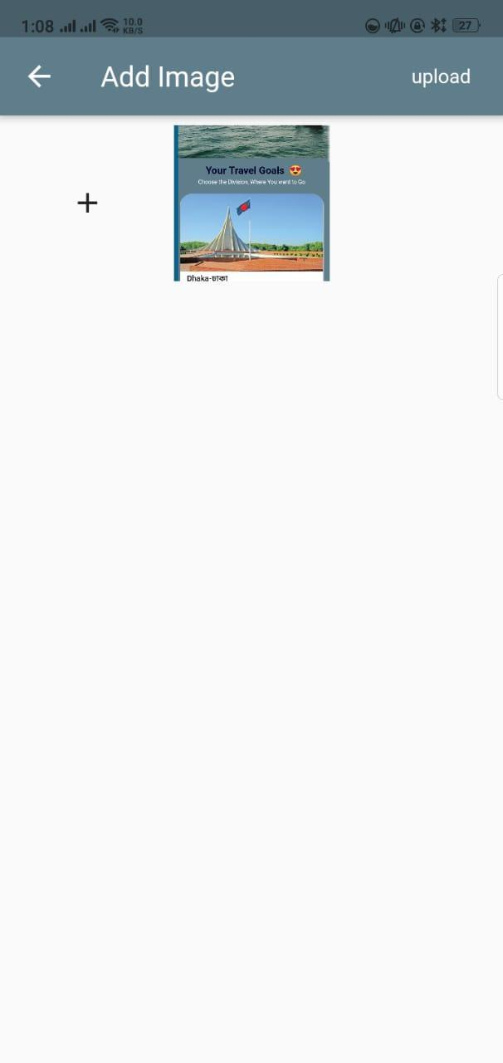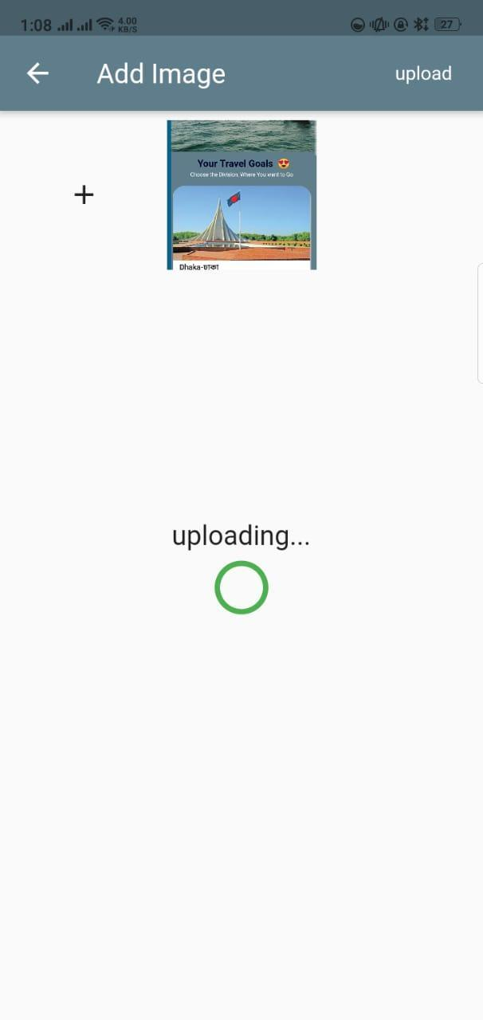

*Figure 55: Uploading Images*

After tapping button, app will open the new page where you need to select images from gallery then, click upload button.

Finally, clicking submit button will update the database with new tourist place details. Navigate to new page.

## **4.5 Details Of Places**

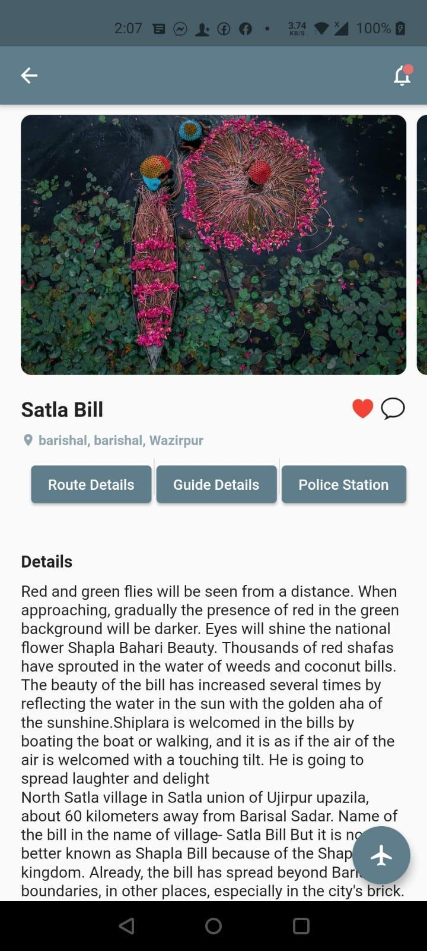

*Figure 56:Details Of Places*

When user want to know about any tourist places and after clicking there, they will navigate to details of that place. Below images, there are three buttons where user can get Route Details, Guide Details and Police Station Details.

### Route Details

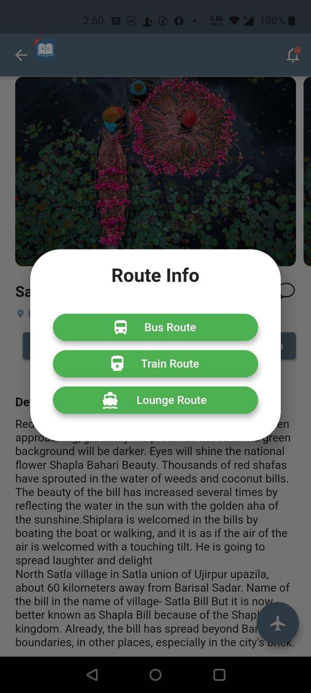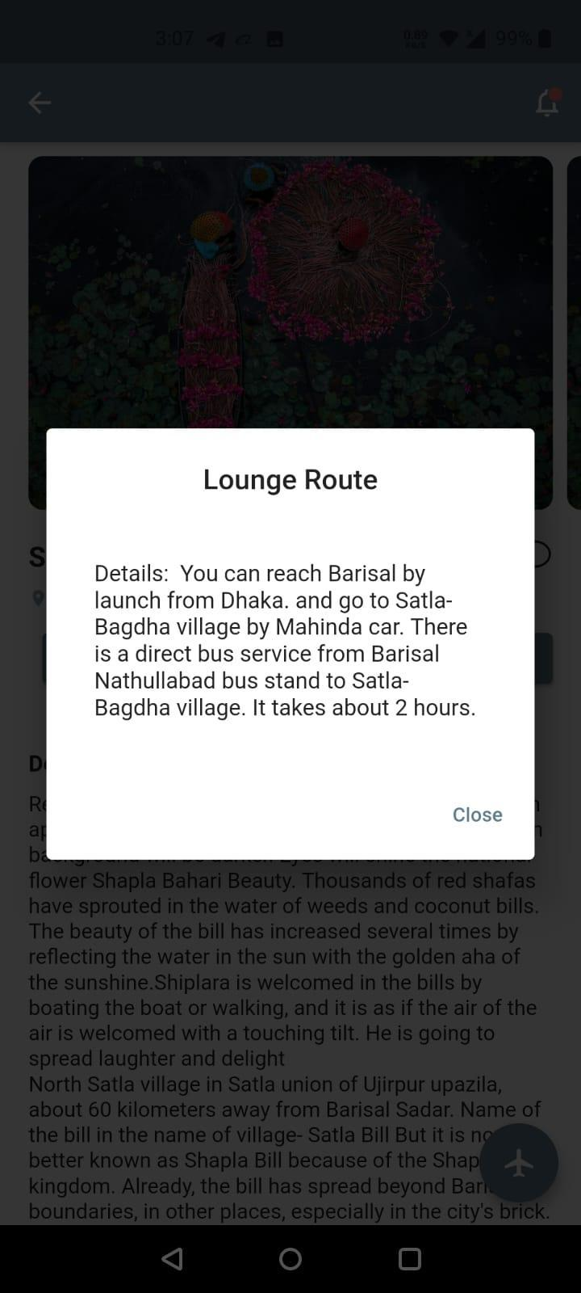

*Figure 57:Three means of Transportation*

Here, we will get all kind of route details like Bus Route, Train Route and Lounge Route by clicking on these buttons.

### Guide Details

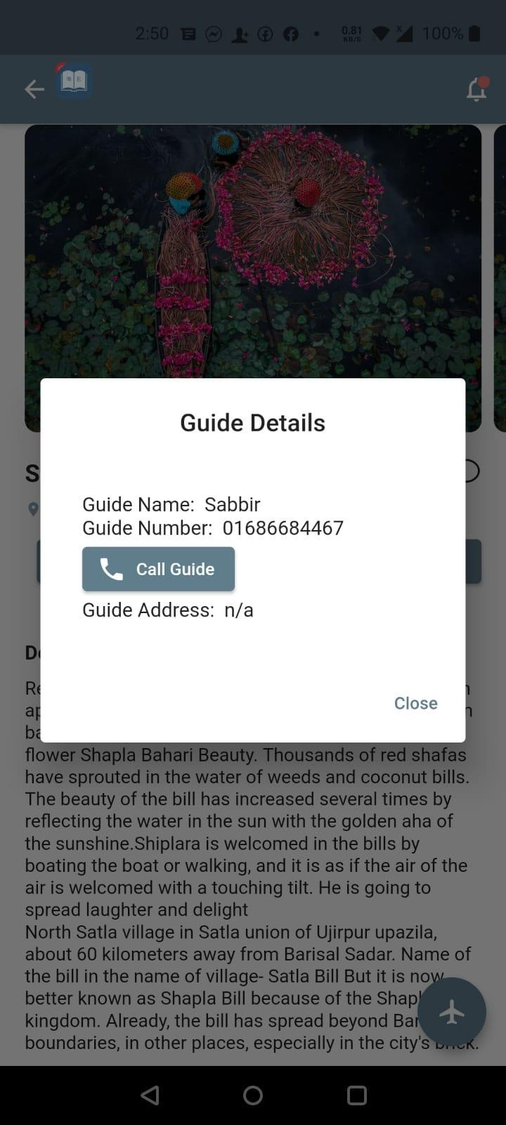

*Figure 58:Information of Tour Guide*

Next to Button Route details is Guide Details, after clicking that button, user can get guide information about selected tourist place. And when user press call button, he/she will be redirected to inbuilt phone calling interface.

### 4.6.3 Police Station Details

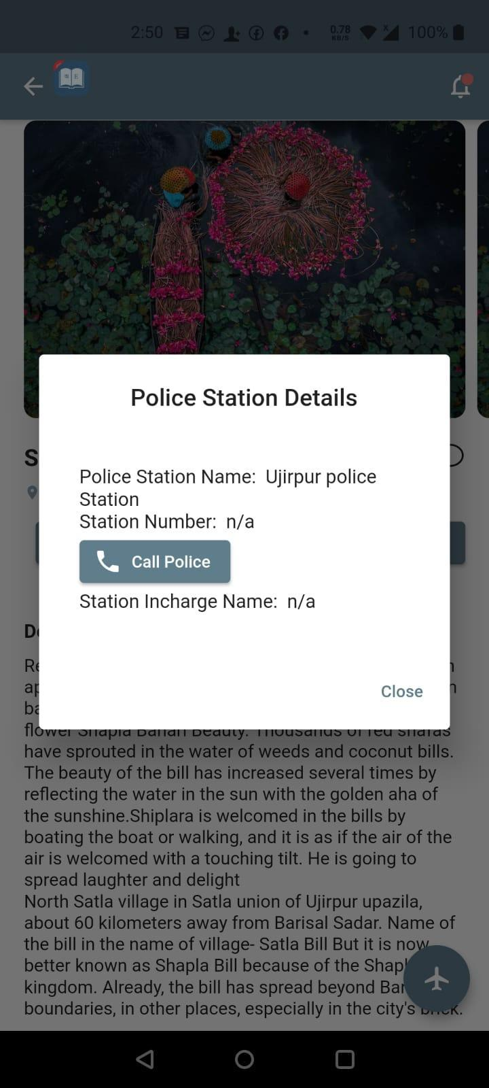

*Figure 59:Local Police Station Details*

Next to Button Guide details is Police Station Details button, after clicking that button, user can get local police station information about selected tourist place. And when user press call button, he/she will be redirected to inbuilt phone calling interface.

### 4.6.4 Airplane icon

*Figure 60: Navigate to Selected Tourist place*

When we search or went manually to see more details of specific tourist place then below-right corner has button with Airplane icon after clicking that use will navigated to map where that tourist place is located.

## **Search Places**

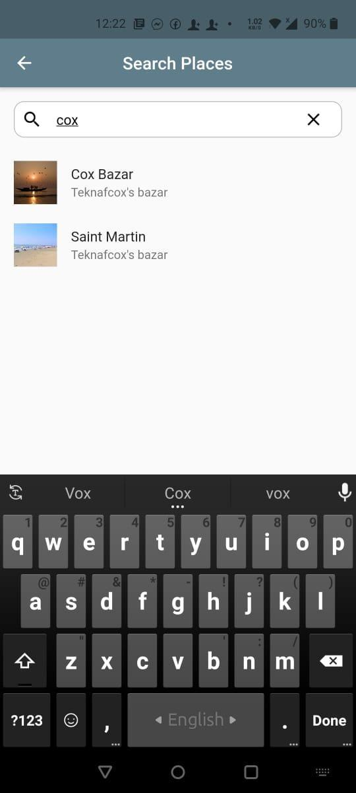

*Figure 61: Search by Placename, District and Division*

User can search by placename, division and district and view details easily and smoothly by clicking search pane.

## **Emergency Contact**

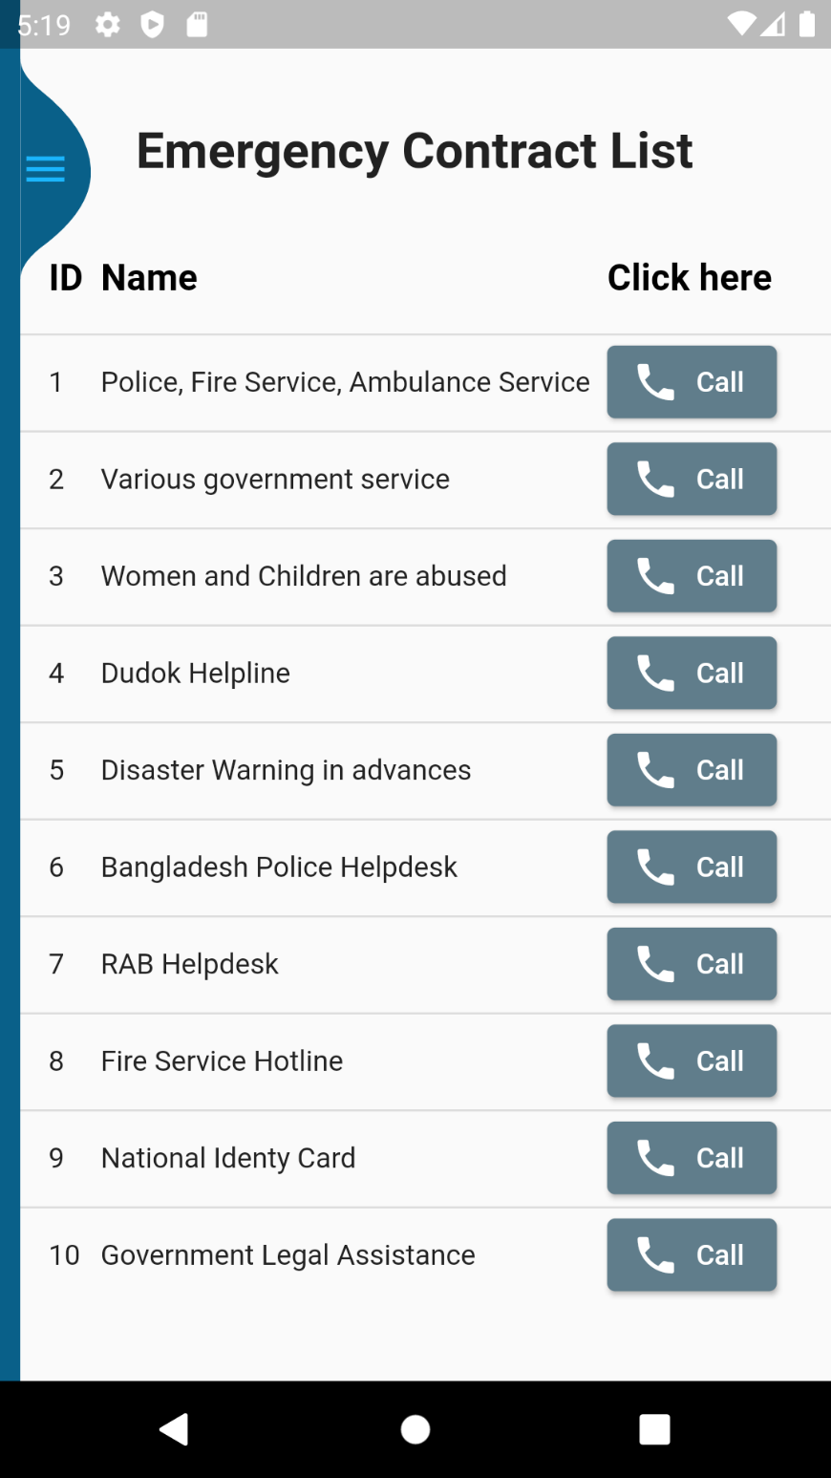

*Figure 62:Emergency Contact*

User can contact to the above-mentioned helpline numbers at tourist places.

## **show newly added place**

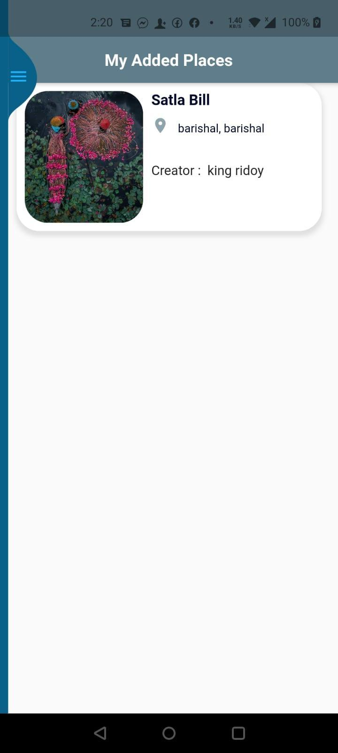

*Figure63: show newly added place*

This page will help user to review what they uploaded.

# Conclusion

# The project ‘Visit Bangladesh’ is an android application designed to assist domestic and foreign tourists. Above mentioned, technical and user manual helps to setup and use apps.